Name: DIVYANSH GUPTA

Roll no: 22CS3025

Lab-08

**T1:**

import React, { useState } from 'react';

const CurrencyConverter = () => {

// State variables

const [amount, setAmount] = useState('');

const [fromCurrency, setFromCurrency] = useState('USD');

const [toCurrency, setToCurrency] = useState('EUR');

const [convertedAmount, setConvertedAmount] = useState('');

// Hard-coded exchange rates

const exchangeRates = {

USD: {

EUR: 0.85,

GBP: 0.72,

CAD: 1.27

// Add more currencies as needed

},

EUR: {

USD: 1.18,

GBP: 0.85,

CAD: 1.48

// Add more currencies as needed

},

GBP: {

USD: 1.39,

EUR: 1.18,

CAD: 1.74

// Add more currencies as needed

},

CAD: {

USD: 0.79,

EUR: 0.68,

GBP: 0.57

// Add more currencies as needed

}

};

// Function to handle amount change

const handleAmountChange = (event) => {

const value = event.target.value;

setAmount(value);

};

// Function to handle from currency change

const handleFromCurrencyChange = (event) => {

const value = event.target.value;

setFromCurrency(value);

};

// Function to handle to currency change

const handleToCurrencyChange = (event) => {

const value = event.target.value;

setToCurrency(value);

};

// Function to handle conversion

const handleConvert = () => {

const exchangeRate = exchangeRates[fromCurrency][toCurrency];

const result = parseFloat(amount) * exchangeRate;

setConvertedAmount(result.toFixed(2));

};

return (

<div>

<h1>Currency Converter</h1>

<div>

<label>Amount:</label>

<input type="number" value={amount} onChange={handleAmountChange} />

</div>

<div>

<label>From Currency:</label>

<select value={fromCurrency} onChange={handleFromCurrencyChange}>

<option value="USD">USD</option>

<option value="EUR">EUR</option>

<option value="GBP">GBP</option>

<option value="CAD">CAD</option>

</select>

</div>

<div>

<label>To Currency:</label>

<select value={toCurrency} onChange={handleToCurrencyChange}>

<option value="USD">USD</option>

<option value="EUR">EUR</option>

<option value="GBP">GBP</option>

<option value="CAD">CAD</option>

</select>

</div>

<button onClick={handleConvert}>Convert</button>

<div>

{convertedAmount && (

<p>

Converted Amount: {convertedAmount} {toCurrency}

</p>

)}

</div>

</div>

);

};

export default CurrencyConverter;

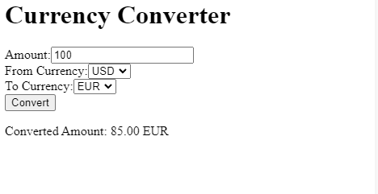

**T2:**

import React, { useState, useEffect } from 'react';

const Stopwatch = () => {

// State variables

const [isRunning, setIsRunning] = useState(false);

const [elapsedTime, setElapsedTime] = useState(0);

// Function to start the timer

const startTimer = () => {

setIsRunning(true);

};

// Function to pause the timer

const pauseTimer = () => {

setIsRunning(false);

};

// Function to reset the timer

const resetTimer = () => {

setIsRunning(false);

setElapsedTime(0);

};

useEffect(() => {

let intervalId;

if (isRunning) {

intervalId = setInterval(() => {

setElapsedTime((prevElapsedTime) => prevElapsedTime + 1);

}, 1000);

} else {

clearInterval(intervalId);

}

return () => clearInterval(intervalId);

}, [isRunning]);

// Function to format time in HH:MM:SS format

const formatTime = (time) => {

const hours = Math.floor(time / 3600);

const minutes = Math.floor((time % 3600) / 60);

const seconds = time % 60;

const formattedTime = [

hours.toString().padStart(2, '0'),

minutes.toString().padStart(2, '0'),

seconds.toString().padStart(2, '0')

].join(':');

return formattedTime;

};

return (

<div>

<h1>Stopwatch</h1>

<div>

<p>{formatTime(elapsedTime)}</p>

</div>

<div>

{!isRunning ? (

<button onClick={startTimer}>Start</button>

) : (

<button onClick={pauseTimer}>Pause</button>

)}

<button onClick={resetTimer}>Reset</button>

</div>

</div>

);

};

export default Stopwatch;

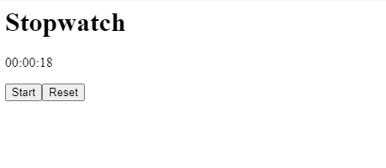

**T3:**

import React, { useState, useEffect } from 'react';

const MessagingApp = () => {

// State variables

const [conversations, setConversations] = useState([]);

const [selectedConversation, setSelectedConversation] = useState(null);

const [newMessage, setNewMessage] = useState('');

// Simulated messages

const simulatedMessages = {

conversation1: [

{ id: 1, text: 'Hello!', sender: 'user1' },

{ id: 2, text: 'Hi there!', sender: 'user2' },

],

conversation2: [

{ id: 1, text: 'How are you?', sender: 'user1' },

{ id: 2, text: 'I\'m fine, thanks!', sender: 'user2' },

],

};

useEffect(() => {

// Simulated conversations

const conversationsData = [

{ id: 'conversation1', name: 'Conversation 1' },

{ id: 'conversation2', name: 'Conversation 2' },

];

setConversations(conversationsData);

}, []);

// Function to handle conversation selection

const handleConversationSelect = (conversationId) => {

setSelectedConversation(conversationId);

};

// Function to handle message sending

const handleMessageSend = () => {

// Add new message to selected conversation

const updatedMessages = [...simulatedMessages[selectedConversation], { id: Date.now(), text: newMessage, sender: 'user1' }];

simulatedMessages[selectedConversation] = updatedMessages;

setNewMessage('');

};

return (

<div>

<h1>Messaging App</h1>

<div className="conversations">

<h2>Conversations</h2>

<ul>

{conversations.map((conversation) => (

<li key={conversation.id} onClick={() => handleConversationSelect(conversation.id)}>

{conversation.name}

</li>

))}

</ul>

</div>

<div className="messages">

<h2>Messages</h2>

{selectedConversation && (

<div>

{simulatedMessages[selectedConversation].map((message) => (

<div key={message.id} className={message.sender === 'user1' ? 'message sent' : 'message received'}>

{message.text}

</div>

))}

</div>

)}

<div className="message-input">

<input type="text" value={newMessage} onChange={(e) => setNewMessage(e.target.value)} />

<button onClick={handleMessageSend}>Send</button>

</div>

</div>

</div>

);

};

export default MessagingApp;

